Google Cloud CLI / SDK
Version 1 - 01/2023
John Shaffer – Desktop Services


In this document you will learn how to install Google Cloud CLI SDK Components.

Install base package
- Open the Software Center
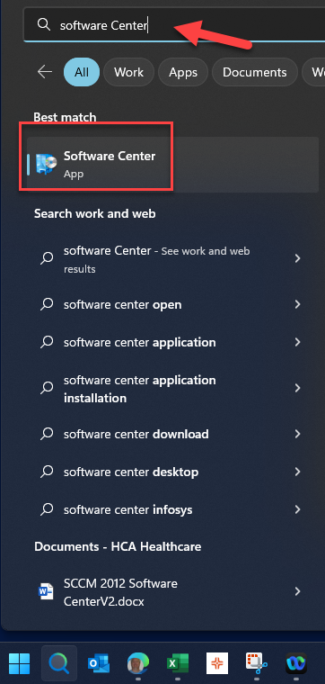

- Find Cloud SDK in the software center
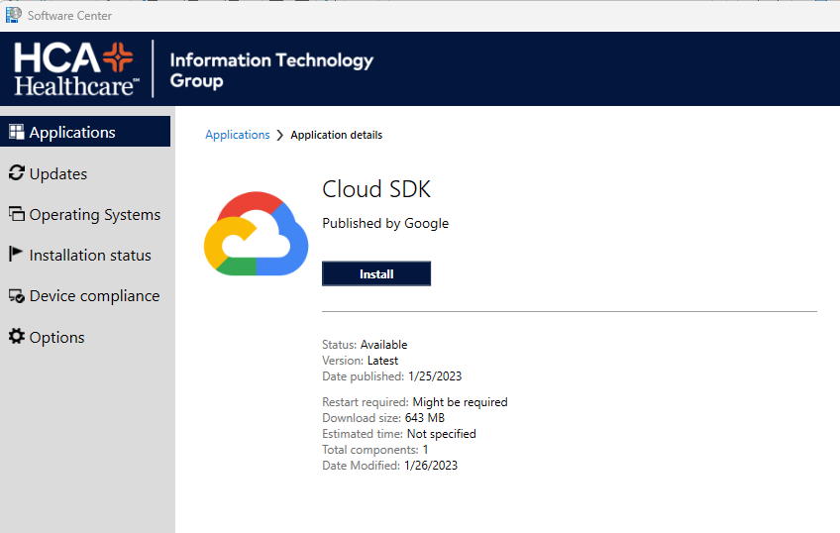.
- Click install. When the install is finished close the command prompt and the software center and reboot your machine.
- Log back in and open and administrative command prompt.

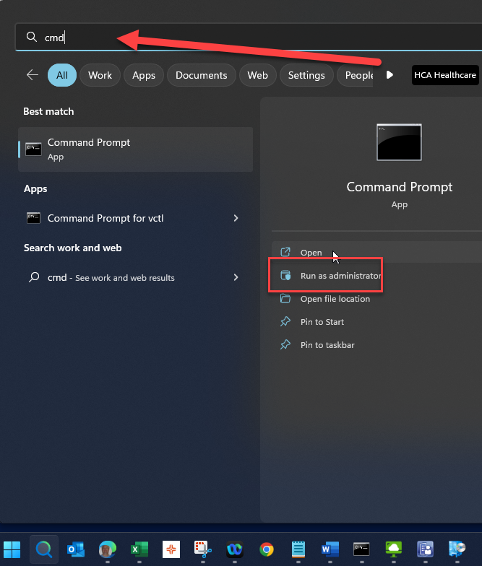
If you need to request administrative rights to install the SDK you can do so here: PAM Express (medcity.net)
- Use the following commands to create a proxy configuration.
"C:\Progra~1\Google\Cloud SDK\bin\gcloud" config set proxy/type http
"C:\Progra~1\Google\Cloud SDK\bin\gcloud" config set proxy/address 10.129.200.7
"C:\Progra~1\Google\Cloud SDK\bin\gcloud" config set proxy/port 80
"C:\Progra~1\Google\Cloud SDK\bin\gcloud" config set proxy/username 3-4@hca.corpad.net
"C:\Progra~1\Google\Cloud SDK\bin\gcloud" config set proxy/password *************
Replace the 3-4 with your user ID and enter your HCA password in the last command.

- Use the following commands to install the components needed. Each component has to be installed completely before the next one can be installed as it creates a staging directory each time.

"C:\Progra~1\Google\Cloud SDK\bin\gcloud" components install alpha
"C:\Progra~1\Google\Cloud SDK\bin\gcloud" components install beta
"C:\Progra~1\Google\Cloud SDK\bin\gcloud" components install cbt
"C:\Progra~1\Google\Cloud SDK\bin\gcloud" components install bigtable
"C:\Progra~1\Google\Cloud SDK\bin\gcloud" components install cloud_sql_proxy
"C:\Progra~1\Google\Cloud SDK\bin\gcloud" components install kubectl
"C:\Progra~1\Google\Cloud SDK\bin\gcloud" components install docker-credential-gcr

When completed enter the command:
"C:\Progra~1\Google\Cloud SDK\bin\gcloud" components list
You should see a list of the components you installed.

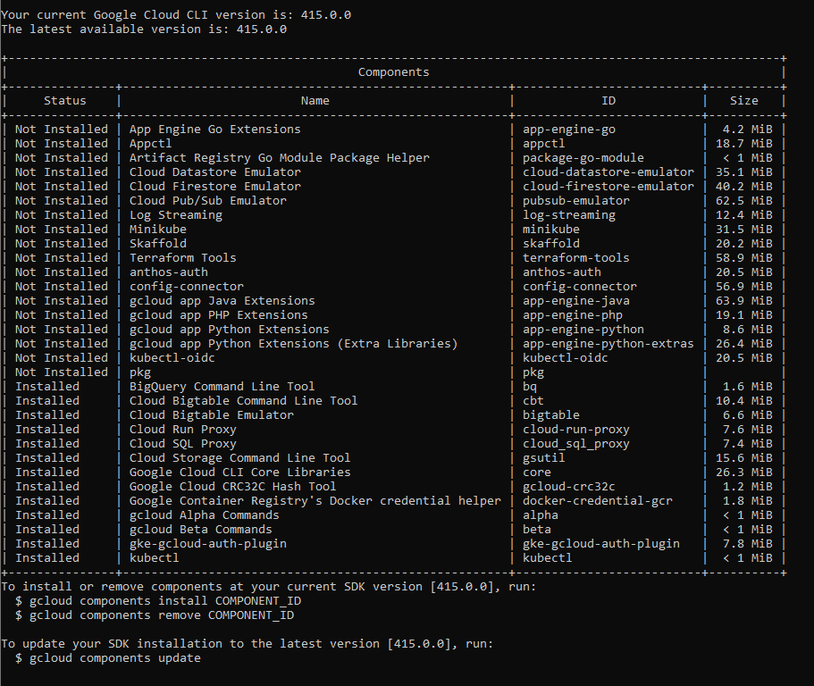
Time to install 1-3 hours depending on number of components needed.

